SOLUTION OF MOLUDE 1:
Question 1: https://www.hackerearth.com/practice/basic-programming/input-output/basics-of-input-output/practice-problems/algorithm/io-exercise/?tab=description
#include <stdio.h>

int main() {
int num;
char s[20];

// Reading input from stdin
scanf("%d", &num);
scanf("%s", s);

// Writing output to stdout
printf("%d\n", num * 2);
printf("%s\n", s);

return 0;
}

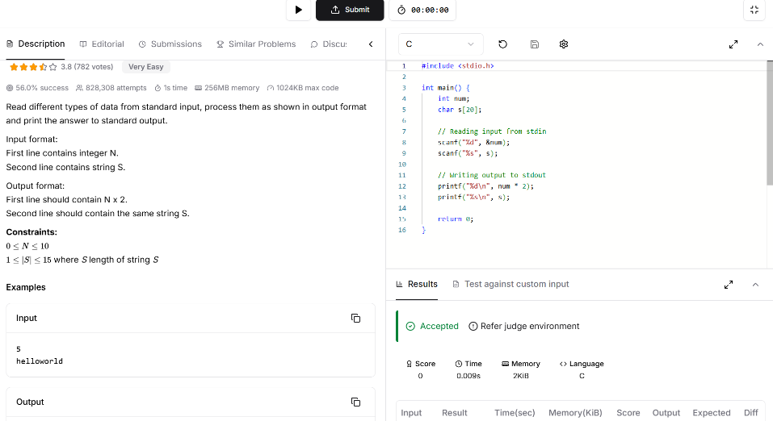

Question 2: https://www.hackerrank.com/challenges/solve-me-first/problem

#include <stdio.h>
#include <string.h>
#include <math.h>
#include <stdlib.h>

int solveMeFirst(int a, int b) {
return a+b;

}

int main() {
int num1,num2;
scanf("%d %d",&num1,&num2);
int sum;
sum = solveMeFirst(num1,num2);
printf("%d",sum);
return 0;
}

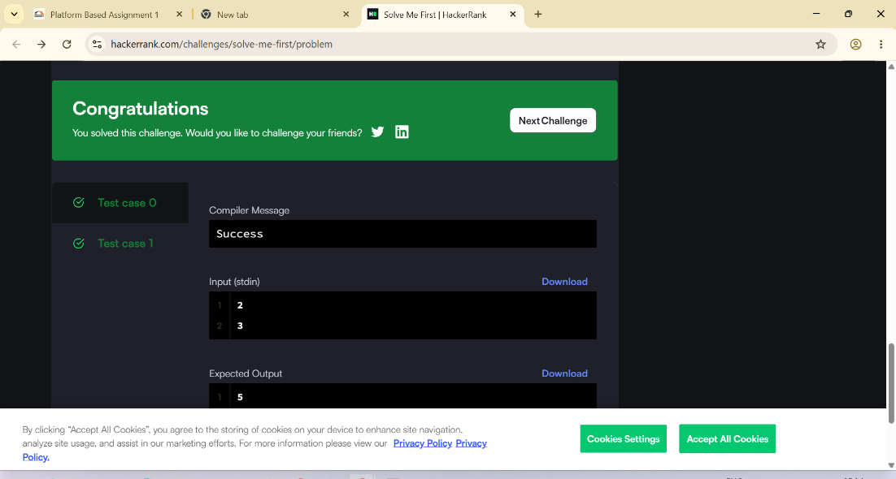

Question 3: https://leetcode.com/problems/add-two-integers/submissions/2192510073/
int sum(int num1, int num2) {
return num1 + num2;

}
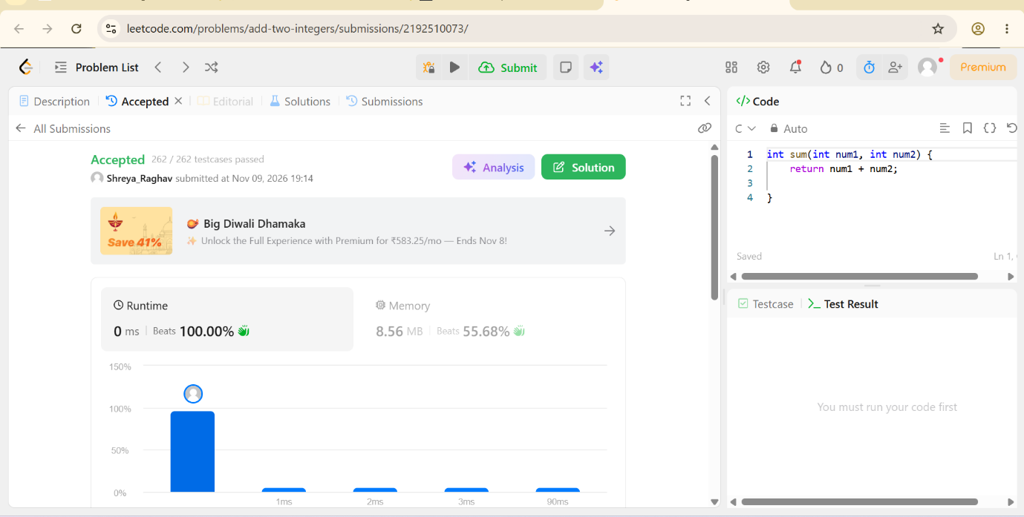

Question 4: https://leetcode.com/problems/calculate-delayed-arrival-time/submissions/2192511510/
int findDelayedArrivalTime(int arrivalTime, int delayedTime) {
return (arrivalTime + delayedTime)%24;

}
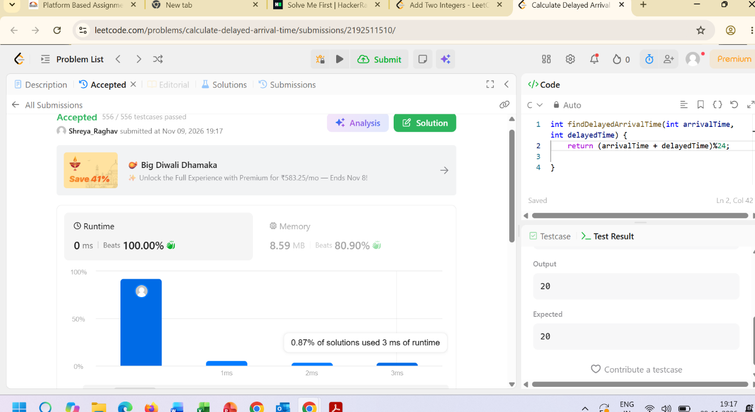

Question 5: https://leetcode.com/problems/total-distance-traveled/submissions/2192513047/
int distanceTraveled(int mainTank, int additionalTank)
{
int totalDistance = 0;

while (mainTank >= 5) {
mainTank -= 5;
totalDistance += 50; // 5 liters * 10 km/liter

if (additionalTank > 0) {
additionalTank -= 1;
mainTank += 1; // Inject 1 liter into the main tank
}
}

// Add distance from any remaining fuel in the main tank (less than 5 liters)
totalDistance += mainTank * 10;

return totalDistance;
}



